11. Perform Affine Transformation on the image.

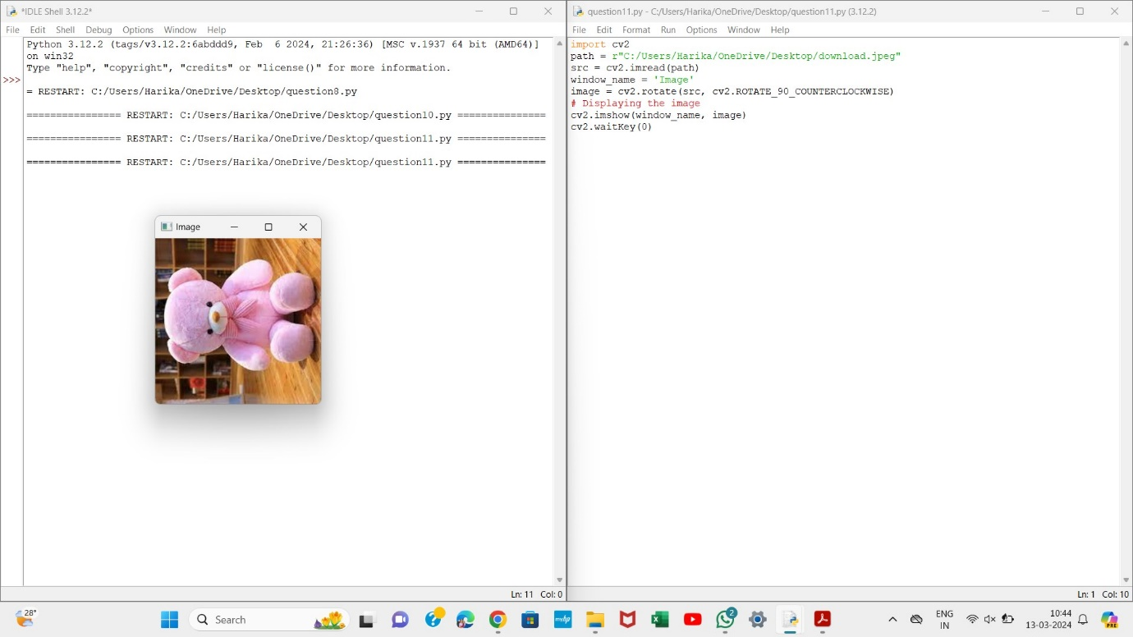

12. Perform Perspective Transformation on the image.

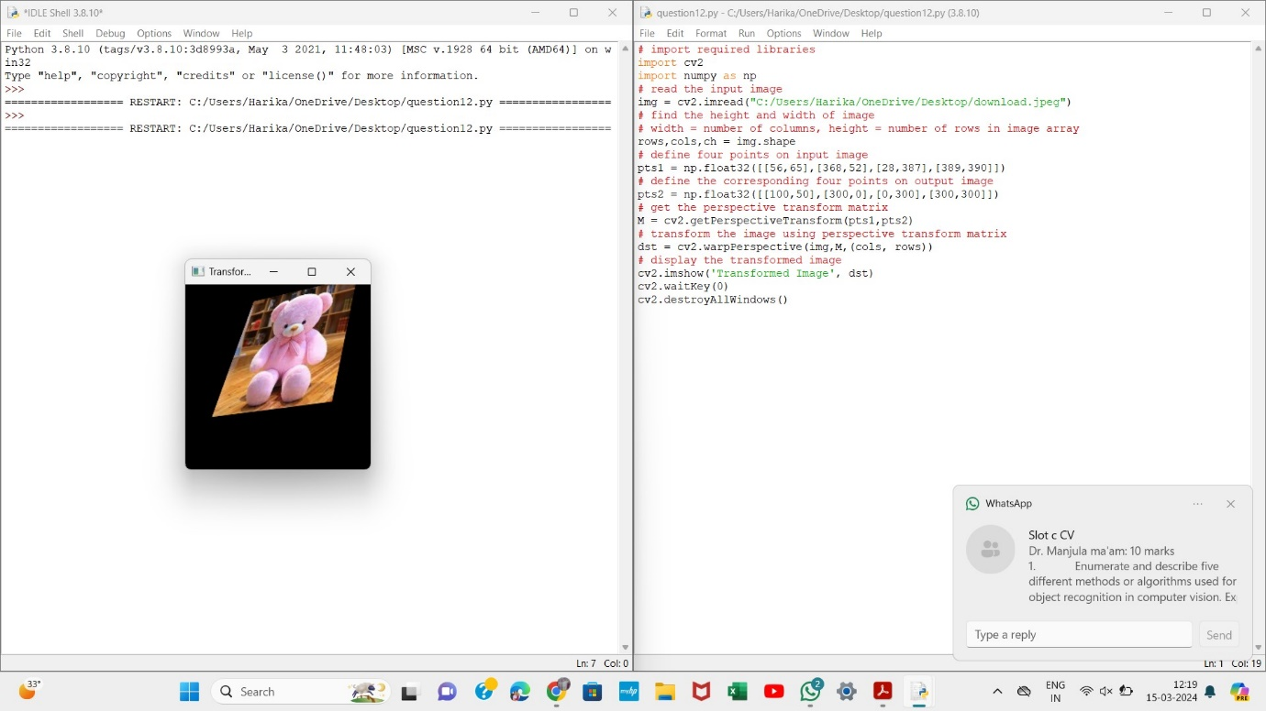

13. Perform Perspective Transformation on the image.

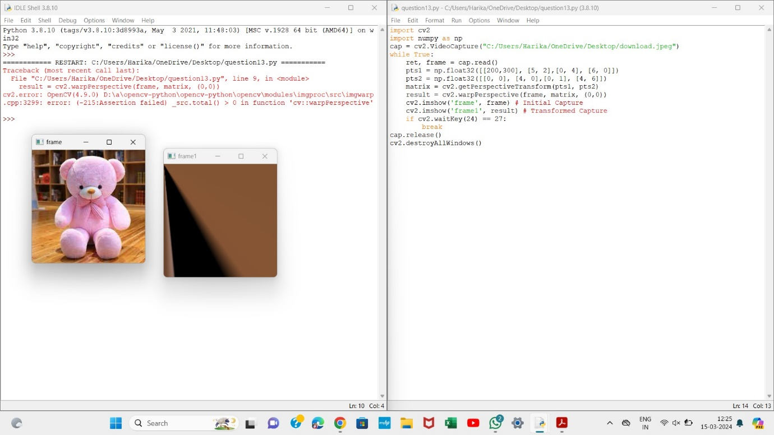

14. Perform transformation using Homography matrix.

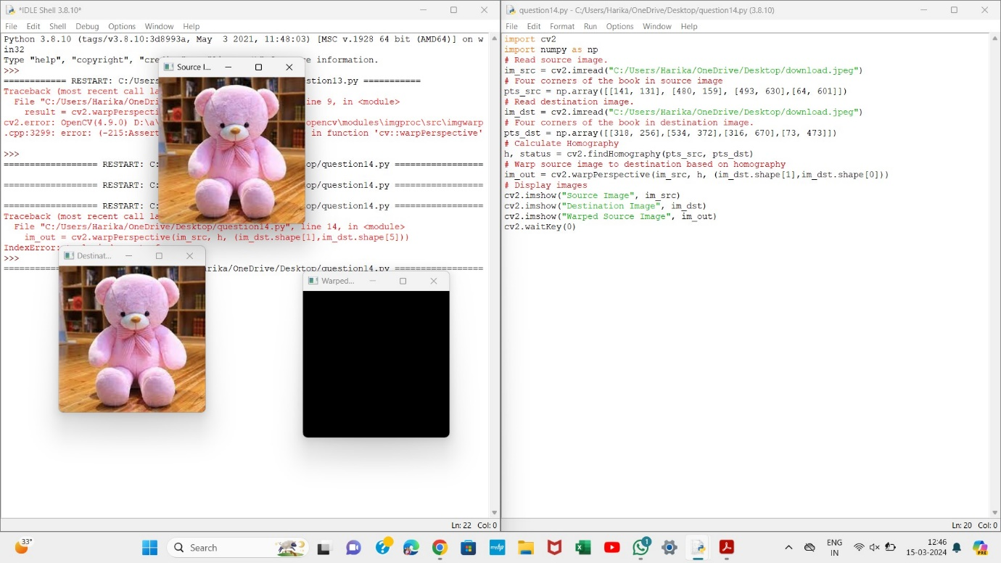

15. Perform transformation using Direct Linear Transformation

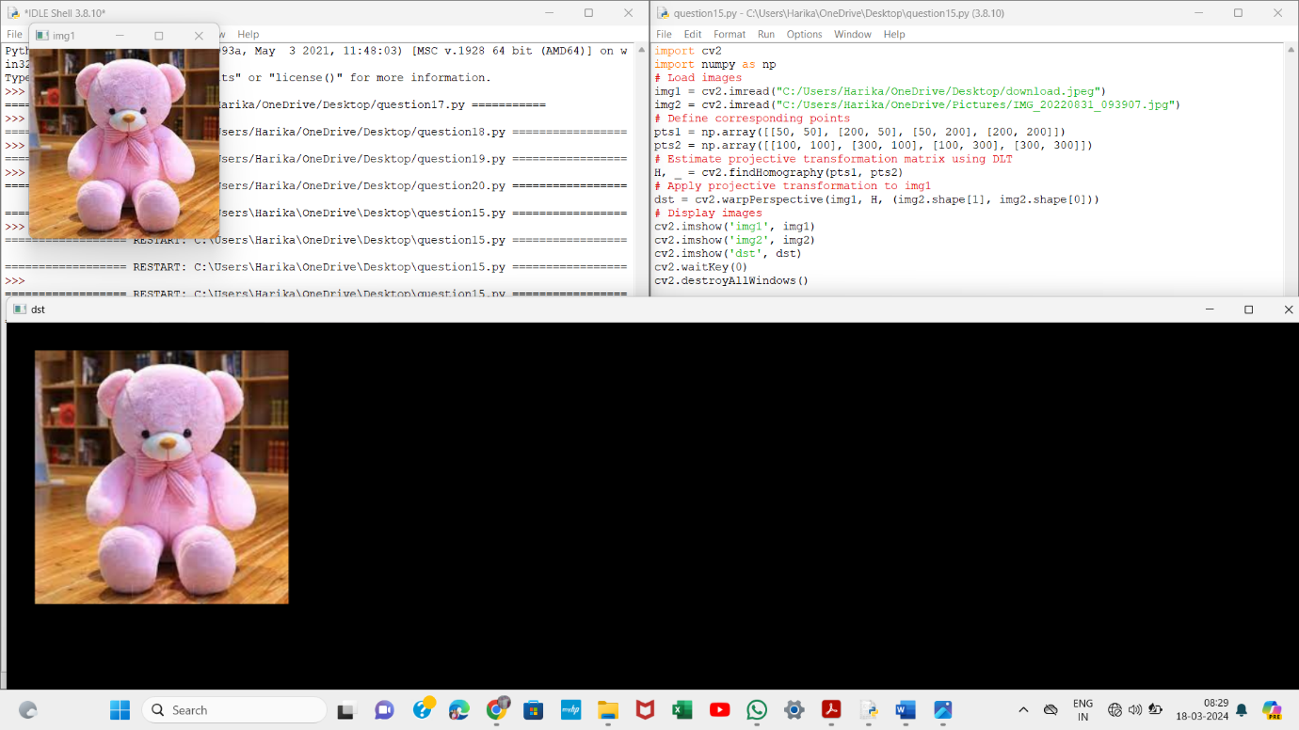

16. Perform Edge detection using canny method

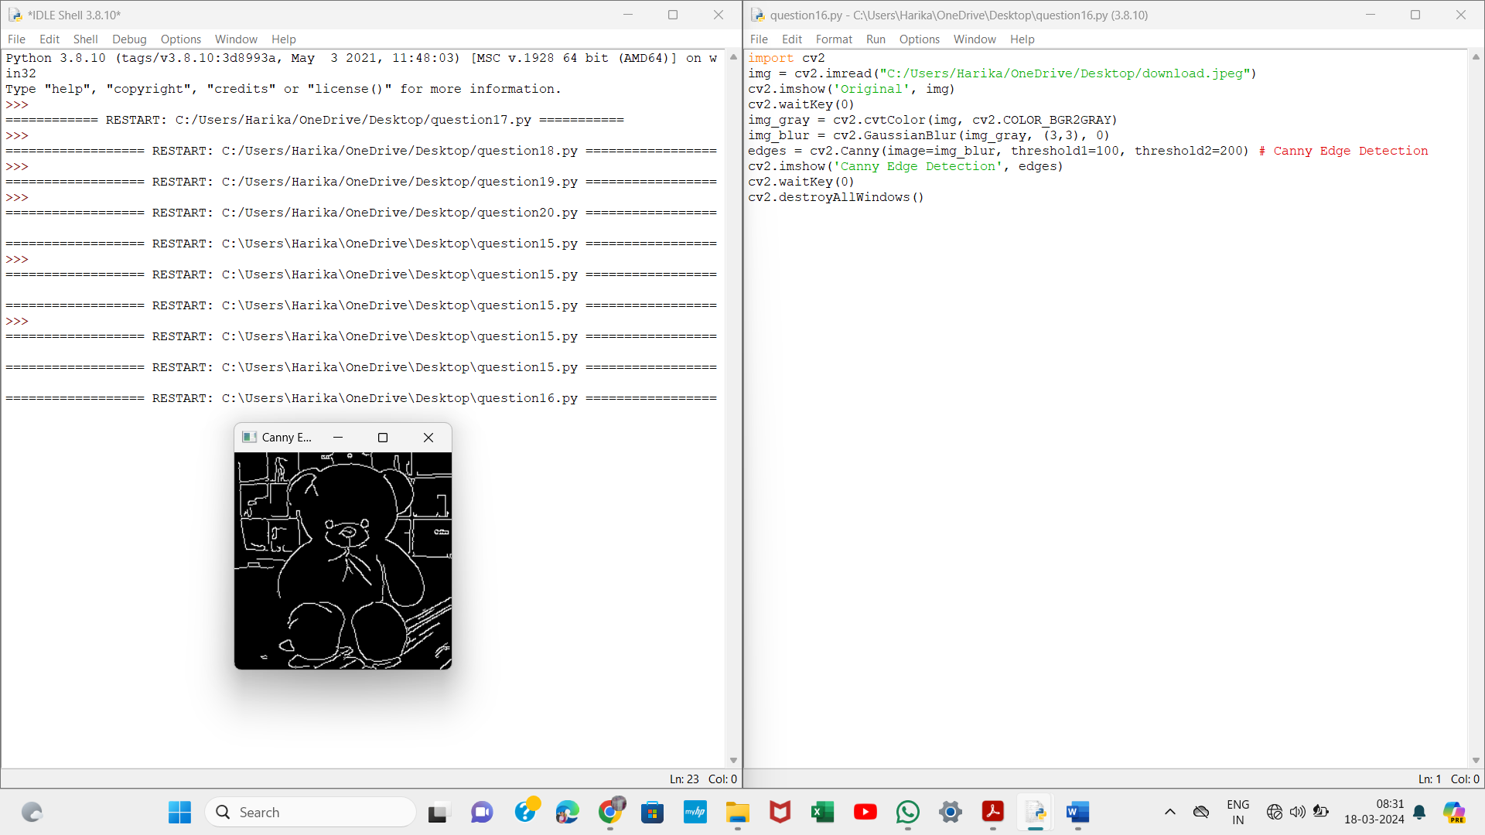

17. Perform Edge detection using Sobel Matrix along X axis

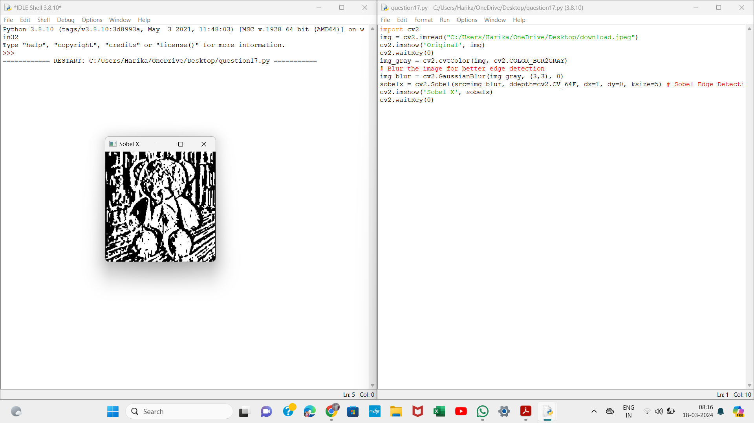

18. Perform Edge detection using Sobel Matrix along Y axis

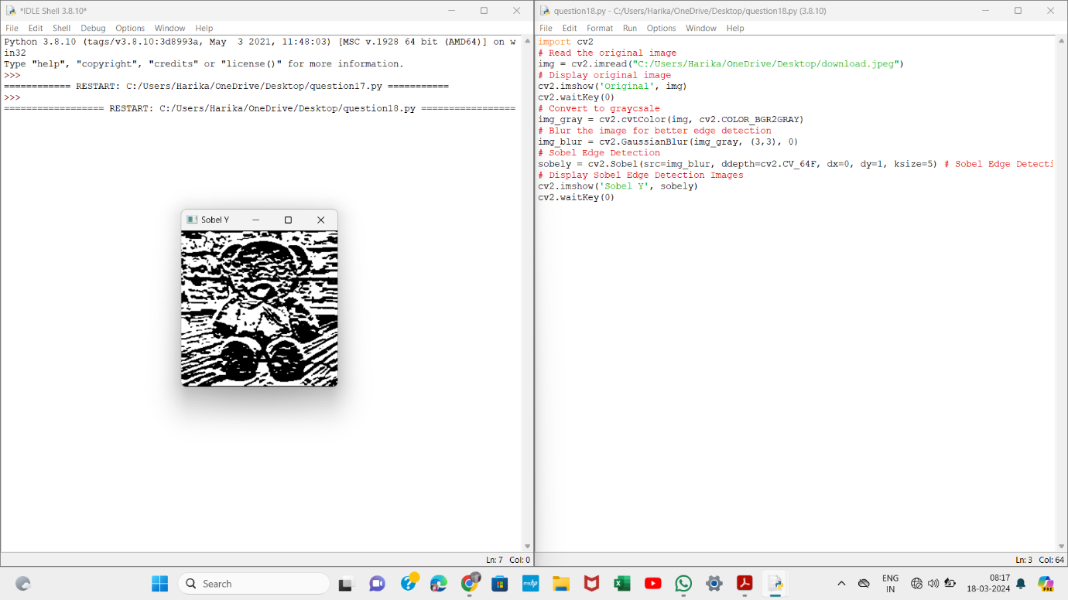

19. Perform Edge detection using Sobel Matrix along XY axis

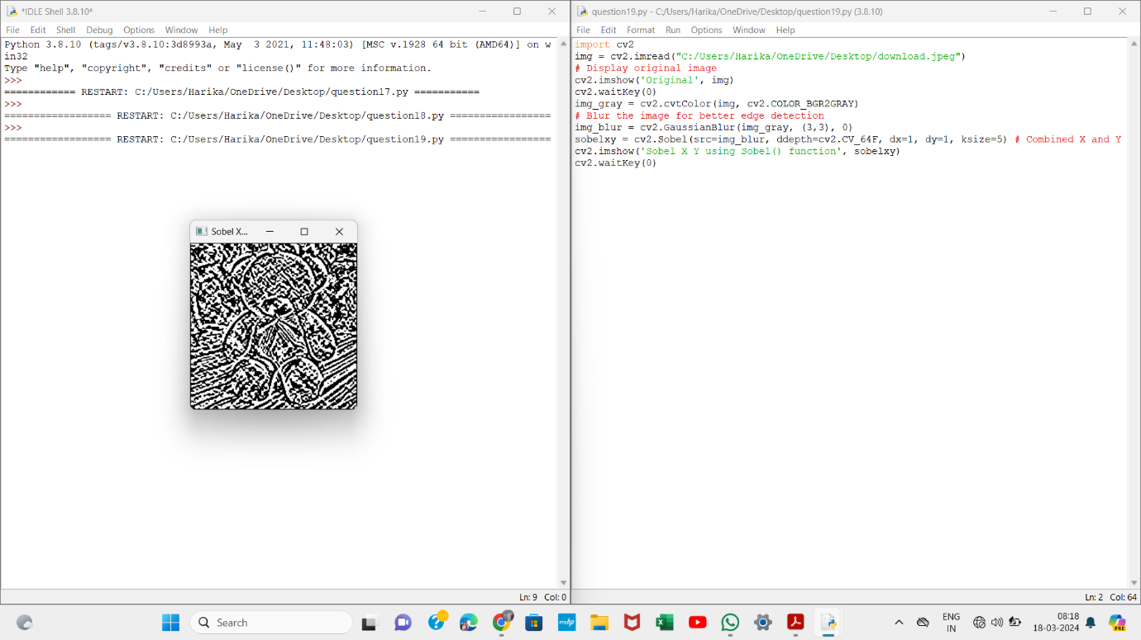

20. Perform Sharpening of Image using Laplacian mask with negative centre coefficient.

